DBMS – SELLER AND INVENTORY MANAGEMENT
StyleNova – Fashion Products E-Commerce Order Management System

1. Database Design
1.1 Seller Table
Attribute | Data Type | Constraint | Description
Seller_ID | INT | Primary Key | Unique identifier for each seller
Seller_Name | VARCHAR(100) | NOT NULL | Name of the seller
Business_Name | VARCHAR(100) | NOT NULL | Business name of the seller
Email | VARCHAR(100) | UNIQUE | Seller email address
Phone | VARCHAR(15) | — | Seller contact number
Address | VARCHAR(200) | — | Seller address
1.2 Inventory Table
Attribute | Data Type | Constraint | Description
Inventory_ID | INT | Primary Key | Unique identifier for inventory record
Product_ID | INT | Foreign Key | References Product.Product_ID
Seller_ID | INT | Foreign Key | References SN_SellerDetails.Seller_ID
Quantity_Available | INT | NOT NULL | Available stock quantity
Last_Updated | DATE | — | Date of last stock update
2. Primary and Foreign Key Relationship
SN_SellerDetails → SN_InventoryDetails
• SN_SellerDetails.Seller_ID → Primary Key
• SN_InventoryDetails.Inventory_ID → Primary Key
• SN_InventoryDetails.Seller_ID → Foreign Key referencing SN_SellerDetails.Seller_ID
• Relationship: One-to-Many (1:M)
• One seller can manage inventory records for multiple products.

Product → SN_InventoryDetails
• Product.Product_ID → Primary Key
• SN_InventoryDetails.Product_ID → Foreign Key referencing Product.Product_ID
• Relationship: One-to-One (1:1)
• Each product has one inventory record for stock tracking.

Relationship Structure: SN_SellerDetails → Product → SN_InventoryDetails
3. Table Creation
3.1 Create Seller Table
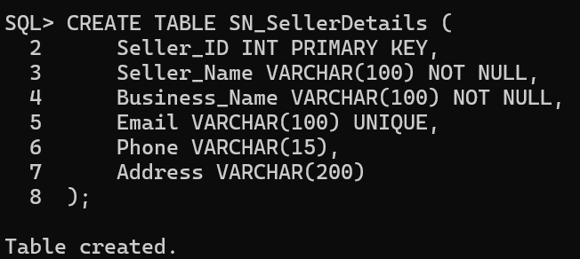
3.2 Create Inventory Table
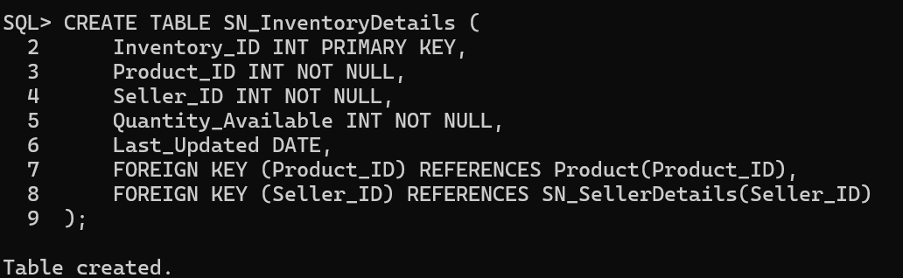

4. Data Insertion
4.1 Seller Records
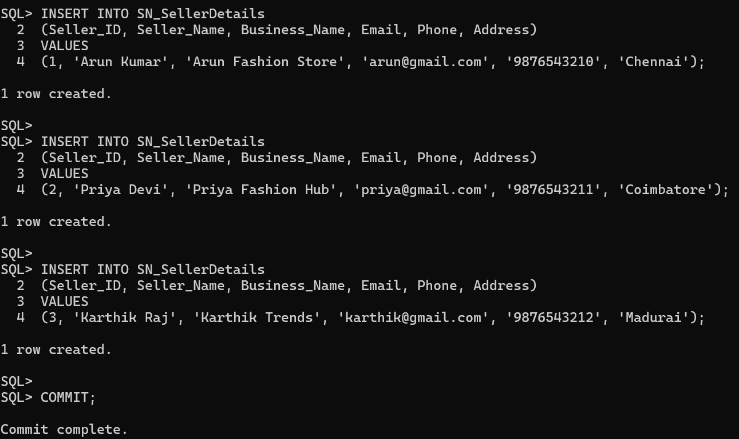
4.2 Inventory Records
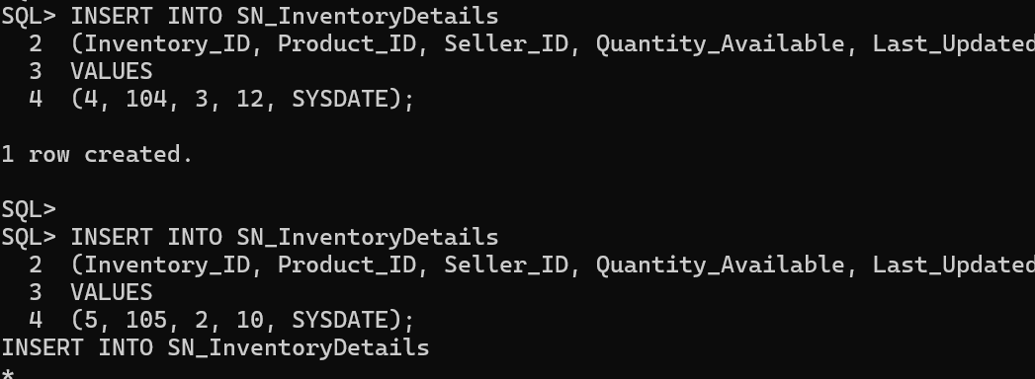
5. Maintain Seller Product Information
5.1 Display Seller Records
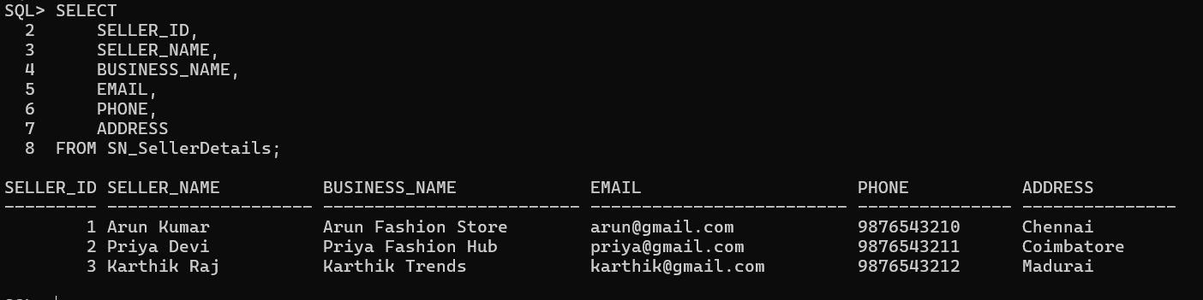
5.2 Display Inventory Records
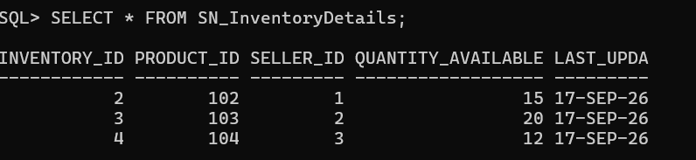

5.3 Display Seller, Product and Stock Information
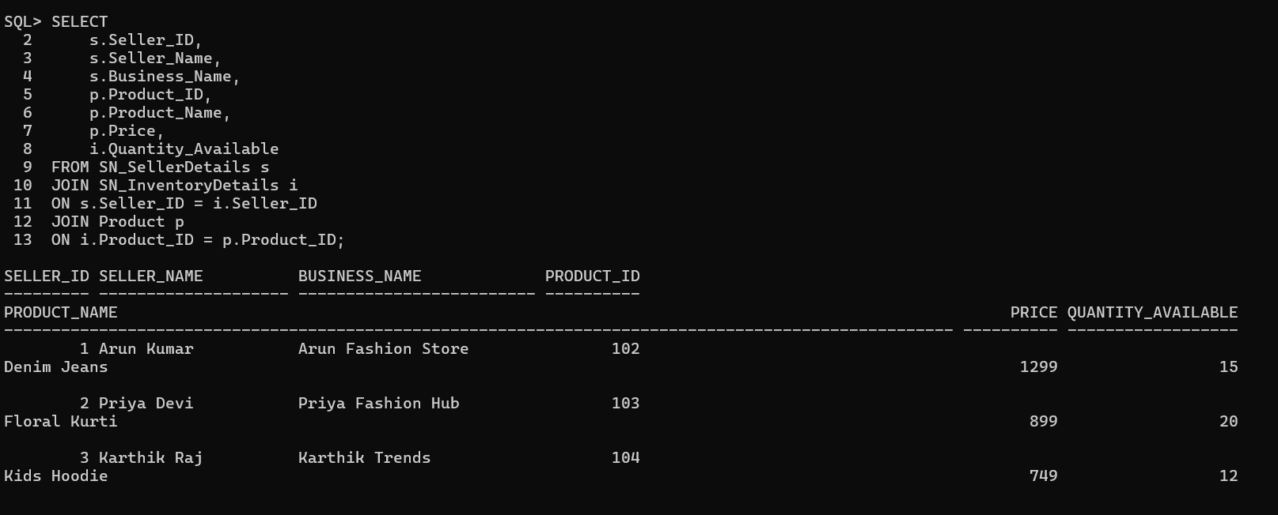

6. Track Available and Unavailable Products
6.1 Available Products
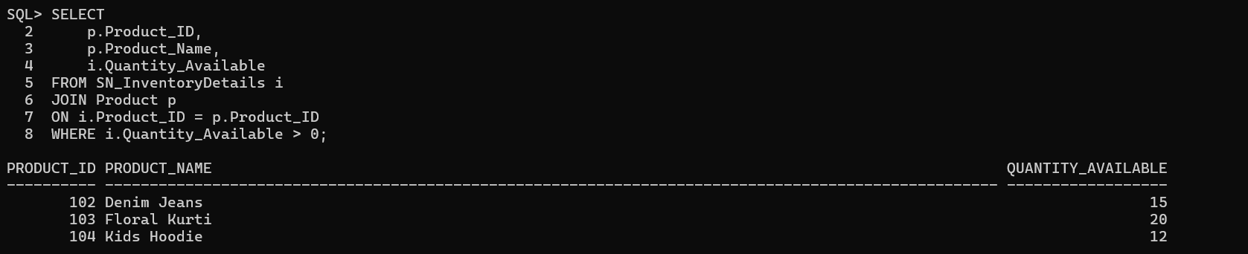
6.2 Unavailable Products
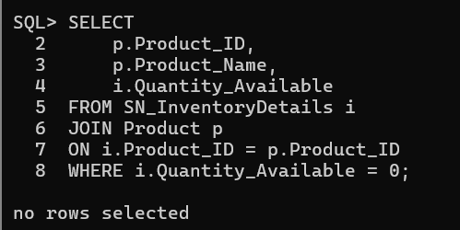
6.3 Product Status
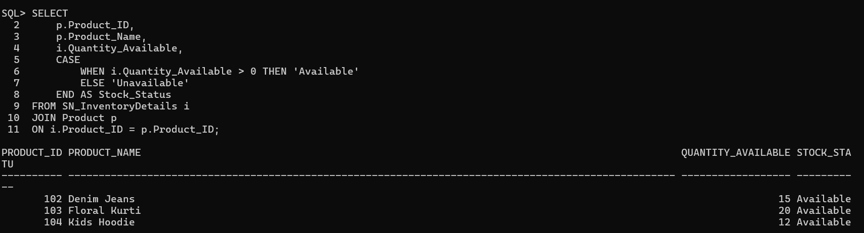
7. Inventory Update
Update the available stock quantity of Cotton T-Shirt.
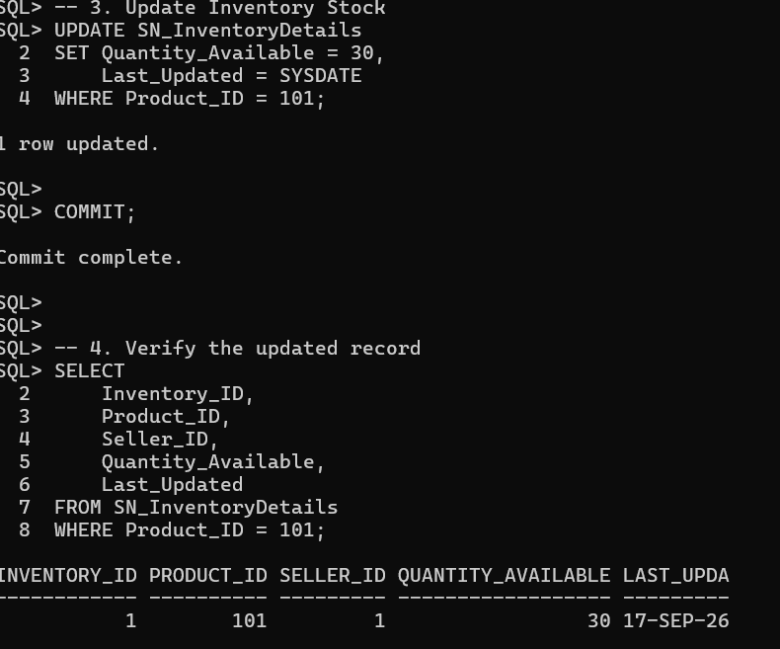
8. Inventory Status Reports
8.1 Complete Inventory Report
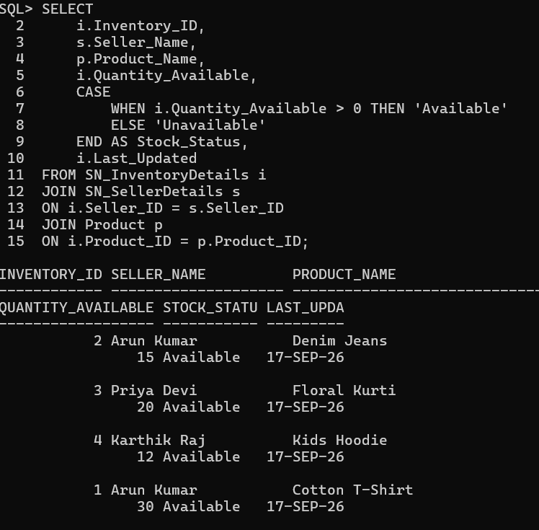
8.2 Available and Unavailable Product Count
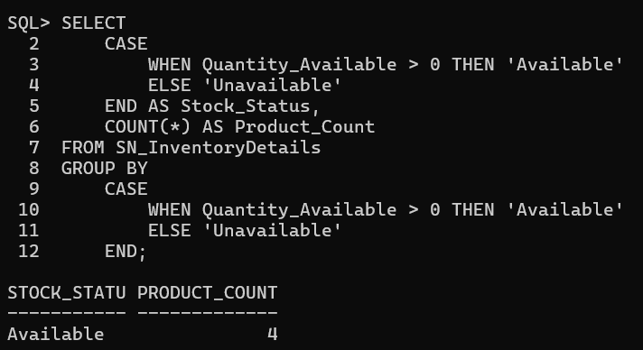
8.3 Total Stock by Seller
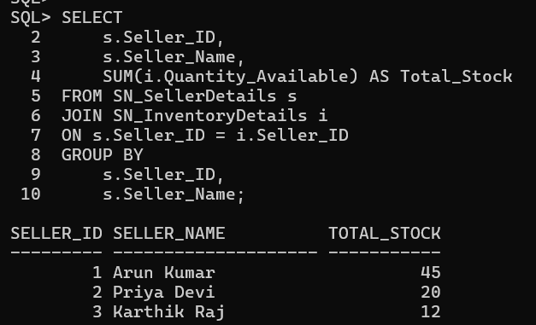
8.4 Products with Zero Stock
